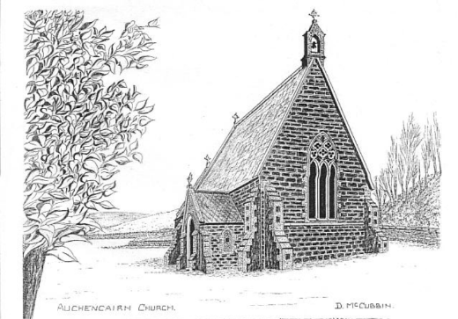

BARK
Buittle Auchencairn Rerrick Kelton

Dear Friends,

It has been a difficult couple of years and we seem to be no further on. Although we were told that Kelton was going on the market as all the paperwork had been completed, it has never managed to reach the For Sale page on the Church of Scotland website. In one way it's frustrating as we are in limbo, on the other it's wonderful as we have celebrated another Christmas in our beautiful church. Until it is sold - may it take as long as possible - we will continue to worship there on the 1st and 3rd Sundays of the month.

Life is funny sometimes. things we take for granted look as though they are about to slip away from us as things change and so called " improvements" are put in place.
It's good to know that there is one thing that never changes. And that is God's love for us.

Wishing you a happy Easter.
Yours in Christ, Alison

The colder days of late autumn and winter can mean that everything slows down and you may think that little or nothing has been happening in church lately. If you keep an eye on our gates and notice board at Auchencairn though, you will be able to keep up to date with what is happening and we try to put posters up in the village(s) too.
Over Christmas
We had a warm church to welcome everyone to our evening Carol Service and the pews were almost full. We were not only glad to welcome Mums, Dads, brothers and sisters, Grans and Grandads, aunts and uncles and who knows which other relatives and friends but also the children from Auchencairn Primary School who came along to share their musical talent. The children’s singing was wonderful and a special mention must be made of the soloist who sung so beautifully. There was also a search for all the people (and animals) who should have been in the strangely empty stable but the children soon found them waiting around the church and returned them safely to where they should have been. The congregation sang joyfully and it was good to hear laughter in the church and listen to the chatter as people eventually made their way down to the village hall for a cuppa.
Meanwhile plans are afoot to work with the children throughout the year on different projects.
On the 23rd there was a well attended Candlelight Carol Service in Kelton Church during which the lesson was read by two of our younger members of the congregation and we enjoyed music from George Shanks with his mouth organ.

Nursery Group
We were pleased to have a visit by members of the Auchencairn Nursery group who came along to hear about Christ’s nativity. This was interactive story telling including narration, singing and play. Frankie was the narrator, Jean was the musical director ie. she was in charge of the bells, l joined in as necessary.
It was all very relaxed. The children had cushions to sit on and we sat on the steps in front of the communion table with the stable and the Inn beside us. Each child had one, or two of the character dolls and bells.

As the story was read the children put the characters in the stable at the appropriate time. The Innkeeper and Angel were placed beside the lnn. One child wanted to put everyone into the Inn. As the last King was being put in the stable one little girl saw the Innkeeper standing outside and just started doing her own thing. She unceremoniously stuffed him into the Inn. That last King was next and then the other Kings that were already in the stable took her eye and into the Inn they went too. She was so quick it took us all by surprise, but it was funny and they were soon rescued and put back to their rightful places.
We had three musical interludes, 'Little donkey,' then 'Here we go down to Bethlehem' which we all danced up and down the church aisle, to shaking our bells and making a lot of noise. We sang 'Away in a Manger’ at the end.

The children were all very well behaved and stopped playing their bells as soon as they were asked to. It was a very enjoyable time for everyone. The icing on the cake came at the end of our time together. Each child was given a satsuma and we walked them to the gate. As they were looking at the Nativity display on the church railings one of the children put some shells she had in her pocket on the wall under the baby Jesus as a present. It was very sweet. We hope to do this again with another Bible story.
(Jeanette)
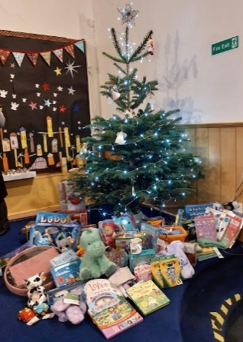
Gift Service
Sunday 10th December saw our Gift Service when members of the congregation brought along presents to give to children who might not otherwise have received any. It’s always very humbling seeing how many gifts a small congregation can bring and they were spread out under the Christmas tree at morning service. Following the service the Minister took the gifts to pass on to Social Work for distribution.
Food Bank. There was a chance at the Carol Service to add to items collected at other services for the Food Bank and thanks go to everyone who contributed. If you would like to give something, goods can be left at any time the church is open.
Cuppa, Chat and Crafts group met on Wednesday mornings up until November. We have now restarted and appreciate the warmer church we have to sit in. A further donation of blankets and baby hats was delivered to the Neo Natal Unit in Dumfries in the autumn for which they were very grateful. You will be made very welcome if you come along to this group and please note it is not compulsory that you craft while you’re there. If you just want a cuppa and a blether that is more than fine. We’ll be pleased to see you.
Not everyone is able to craft but if you would like to contribute to items for the Neo Natal Unit or for our fund raising table, please speak to one of the ladies and they’ll advise what sort of materials you could donate which we could use to make items.
Wildlife garden
Children from Auchencairn primary school recently made their first visit to the church to help make a wildlife garden. They were all so enthusiastic and soon got through the work planned for their visit. They helped clear some of the ground, made a barrier “hedge” to separate the garden from the rest of the area and helped put out food for the birds. They even started weeding the gravel when they ran out of other things to do. All the children worked well, were so keen to help and a delight to work with. They will be back to do more before long. Meantime, if you would like to contribute to the cost of bird food etc. please let us know.
Future plans
You will no doubt be wondering what is happening about all the plans we had for the Auchencairn building. We’re pleased to say that the new infrared heating system was installed in November and has made a real difference to temperature and comfort in the building. We need to wait for permission from the Church of Scotland Trustees for almost everything we want to update in the building and while they took pity on us over the coldness of the church, we are still waiting to hear whether or not we can instal comfortable seating, a small kitchen and indoor toilet facilities. We are frequently in touch with them but as yet do not have a decision.
Library
For a while we had a small library in the church but due to the cold and damp it wasn’t good for the books. We are planning to renew this facility in the future. We also have jigsaws to lend.
Hymn numbers
Thanks go to Stewart Ditchburn who has made a brand new set of numbers for the hymn board at Auchencairn.
SERVICES
There will be a united EASTER SERVICE at Castle Douglas Parish Church on 31 March at 11 a.m. No service in either Kelton or Auchencairn that day.
Our services continue to take place at 0930 each week in Kelton on the 1st and 3rd Sundays and in Auchencairn on the 2nd and 4th Sundays. The service on the 5th Sunday of any month takes place alternately or as advised. We have also tried having services in the Dundrennan and Palnackie village halls.
Previously we delivered our Newsletter to as many people as possible in the parish but in the current financial climate it is just being posted to all our members and active supporters. (Expenses for this edition have been donated). It can also be read on our website (http://www.bengairnparishes.org.uk) and hopefully copies will be available in the village shops. If, however you know of anyone who would like a copy sent to them please get in touch with Mrs Rosemary Gladstone, and of course you could also share your own copy.

